BROMLEY ART SOCIETY
Craft Fair and Exhibition at the Warren Hayes July 2

BAS will take a stall in the main Gingham Goose Summer Craft Market and a separate exhibition space in the Warren Building. This gives us an opportunity to showcase the Society's Artists and activities at the stall while acting as a pointer to the larger exhibition. Gingham Goose events are well attended with a strong track record in the area.

There is no theme to the exhibition, so any subject is welcome provided it is fit for a family audience. The room we will be using as a gallery has plenty of space so the only restriction is the size of our exhibition screens.

Timings of the exhibition are planned to be as follows:

Wednesday 7June

Confirm intention to take part.

If you have not yet done so but would like to take part then please fill in the forms as requested below and also email bromleyartsocietyevents@gmail.com so we are aware.

Wednesday 14 June

Make payment to confirm participation.

Friday 23 June

Return details of work to be hung on screens (unframed work information can be provided on the day)

Sunday 2nd July
8-10am Exhibition set up. A list of unframed work should be brought with your work. The hung work form must be returned in advance.

9.30am-1.30pm and 1.30-5.30pm Steward exhibition
4-5.30pm take down exhibition and pack work.
We very much hope that most Artists will deliver and hang their work personally. If this is a problem for you please let us know as we want to make sure that as many people as possible take part, and we may be able to organise collection and drop off arrangements.

Parking and Travel
The Warren has a large car park and we are planning to give two slots to hang work. It is also not too far from Hayes station/Hayes village if you do not want to use public transport.

The Exhibition
You are invited to hire one screen for sole use, or to exhibit individual works, and/or up to 6 unframed works. It may be possible to use your own browser if discussed in advance.
Please make payment by the 14 June and return details of the works you wish to exhibit by Friday 23 June

This exhibition will require stewarding as it is over two locations within the building and the venue is expected to be very busy - we are planning on 9.30-1.30 and 1.30-5.30 slots but these can be flexible. We are aiming to always have a committee member available so you will not need to deal with sales unless you wish to, but we need supporters. We’d also like some additional volunteers willing to set up and take down screens. Thanks to those of you who have volunteered we do still have a few vacant spaces

This mailing includes a form to include your details and a return a list of work to be hung on screens. If you are still interested but did not let us know that you were intending to take part please fill in these forms and also let me know to help with planning.

Please make payment electronically. If you are not comfortable using online banking please let me know so we can provide another way, bank details are below.

Lists of work in the browser and for cards can be provided when your work is delivered.

We want to use your works to publicise the exhibition both on our own Social media and by the Gingham Goose who are organising the wider event. If you are on social media and have not shared your details please email us as soon as possible.

NB We use the documents you send to create sales lists and price labels. This avoids rekeying and reprinting with all the risks that this brings. If you are unable to use the form the information can be provided in other formats or the details listed in an email or word document rather than sending a jpeg or pdf file which has to be printed out again and rekeyed. NB it helps if you include your name in any files you send it to us.

Costs are as follows:
- Hanging fees are £4 per picture or £15 per screen, 50p per unframed work

- A commission of 10% will be taken on sales

- Work to be brought to the delivery points as advised below

- A list of unframed work should be brought when handing over your work. The hung work form must be returned in advance.

- Unsold work to be collected as per our next email. There is no storage available other than in the Big Yellow storage locker

Please make payment to the account below

Sort Code 09-01-55 Account number 42186802
Account name Bromley Art Society
Please add as reference Exhibition and your surname
If you are not comfortable using online banking please contact exhibitions@bromleyartsociety.org.uk for the address to send your cheque to.

Image of the Hayes Room, in addition to this space the room also has a bar area (sadly not open) and a fireplace alcove.

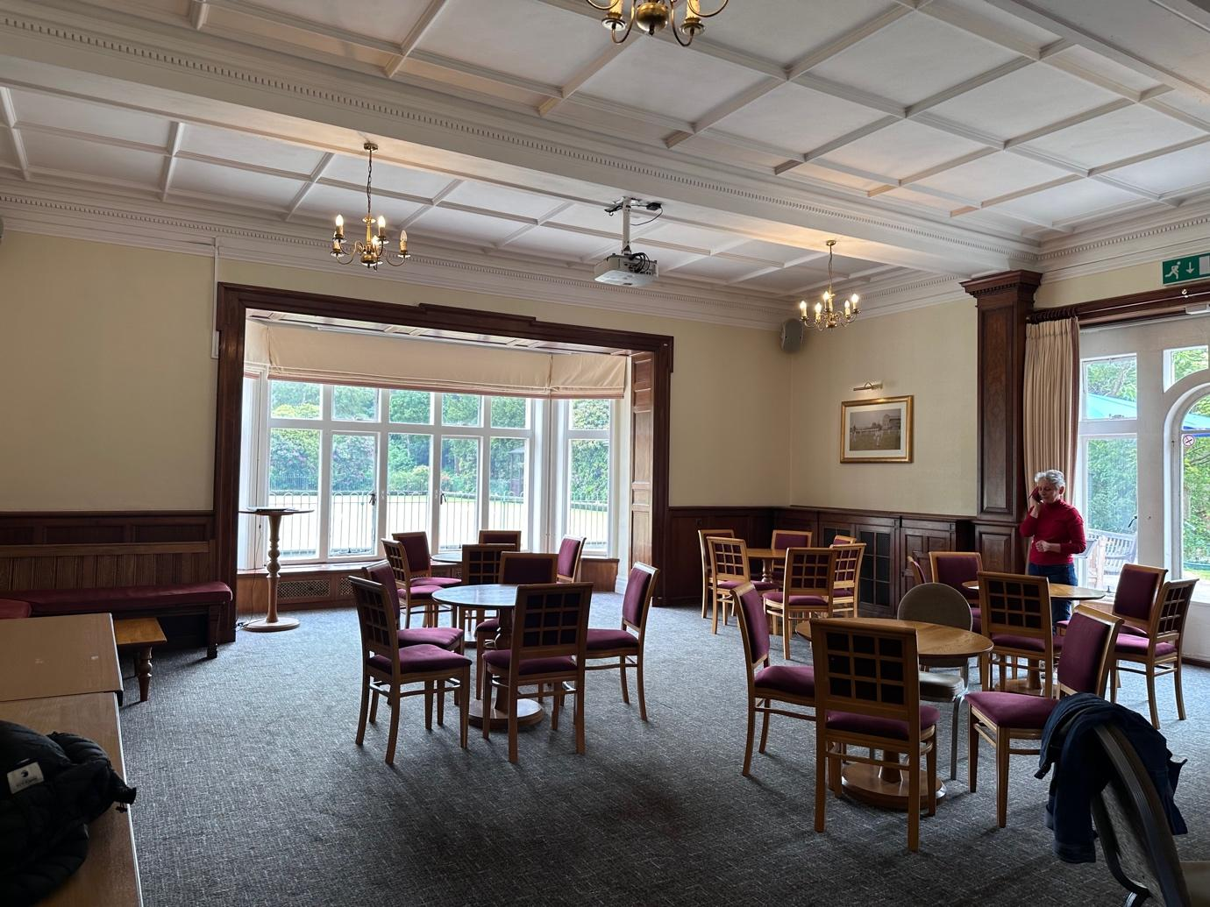

Presenting your work

2 dimensional Hung works

Work will be hung on screens. The hanging committee will provide labels if requested
Please note:
Work for hanging must be securely framed and no larger than 36x36inches (91x91cm) - NB the screens are 1metre by 2metres and hanging space is 96cm wide and approx 1.5m deep
Framed work should be fitted with screws and with picture cord or wire ready for hanging- this is the responsibility of the artist and failure to do this could result in rejection of the work The cord or wire should be knotted away from the centre of the work to ensure the work hangs level.
No clip frames please. Unframed canvases will be accepted provided they are presentable.
Work should be suitable for a family audience.
Pictures should be clearly labelled on the back.
Frames should be of good quality and any glass should be clean inside and out
Work will be sold off the wall
Artists can print their own labels if preferred (maximum size 8.5cmx3.5cm - the size of a business card) . Arial font preferred. If you are unable to do this please let us know at the time you submit your list of works and we can print them on your behalf.
If you are new to our hanging arrangements then you can find details on this website I created for last year’s Beckenham Place Park exhibition https://bppartshow2020.wordpress.com/on-the-day/ NB this is a rough and ready WIP website for use in a different exhibition so please ignore any exhibition specific information.
Browsers

- Artists who wish to use the society’s browsers are welcome to submit up to 6 pieces of unframed work. All paintings should be wrapped and sealed on the reverse side of the painting and clearly labelled. Please no unwrapped or cling-filmed work. If you are proposing to use your own browser please let us know in the form
- Please note:
  - The best wrapping is clear plastic (cellophane) to be found in art shops, Ryman’s and online (there are greener alternatives available now if you wish to avoid plastic).
  - Please no unwrapped or cling-filmed work.
  - A suitable sized stick-on label, an example of which is given below, should preferably be affixed on the reverse or top right hand corner of the work. The label should show the following:

Title
Artist’s Name
Medium
Price

Sticker example, size approx 8cm x 4cm:
Irises
Vincent van Gogh
Oil
£35m

Not for Sale work
One of the ways that the society funds its activities and/or makes a donation to the host location is by commission on sales so we hope that all work will be for sale. If however you would still like to put in a work that is not for sale please note that only 1 work per member is acceptable. All other arrangements for taking part – e.g. stewarding and payment for taking part remain the same.
Three Dimensional Work
It will not be possible to exhibit three dimensional work at this exhibition unless agreed in advance.

Delivery and Collection of Work

Work can be delivered:

Saturday morning 10.30am-11.30am (hanging to be completed by 12 noon).

Sunday morning 8.30am – 10am (NB the Craft Fair event will commence at 10.30 and Makers in the wider Gingham Goose event will be arriving so you will find the car parks busier.

You are responsible for hanging your own work on the screens. If you are delivering one or two works we will do that for you.

NB we are expecting to deliver the screens c10am on Saturday. When you arrive we will be in the Hayes Room. Either through the main doors and turn right or through the archway on the right and left round the building. If you need to bring the car closer to the building to drop off your work please park considerately and move our car ASAP (we will share any additional instructions re this soon)

Collection of work is from 4pm-5pm on Sunday 2nd July

If the above times are a problem for you please let us know in case we can make alternative arrangements as we want everyone who would like to take part to do so.

Any works presented without being strung for hanging will not be hung. In particular the short turnaround time of set up would make this impossible.

Publicity

There will be a poster inside the venue (which is a social club outside of events) and other posters in the surrounding area. We will post on our social media groups as will the Gingham Goose.. Please contact us if you can help. We can send you electronic copies of the poster and social media posts. If you would like to have your work included in pre-publicity please email images of your work by 23 June preferably earlier. All images must be labelled with your name first and then the title of your work. In the same email can you also include any social media handles/links to your website that you have. But most importantly we also rely on participants to spread the word.

COVID arrangements

Although government guidance has been removed please be mindful of COVID risks e.g. by complying with any specific Covid guidance from the exhibition organisers and the venue e.g. consider wearing a face covering, using hand gel, please do not take part if you should be isolating etc. More information will be provided on the day if needed.

Other Terms and conditions

- Exhibits may be paintings, in any medium, textiles, drawings, photography, sculpture, collage or prints of artistic merit
- Exhibits must be original works and not copies of well-known works of art unless labelled as such.
- All exhibits are accepted at the owner’s risk. Due care will be taken, but neither The Warren, Bromley Art Society or fellow Artists can be held responsible for any loss or damage – see information on insurance below.
- The Society does not have insurance against risks such as theft, fire or accidental damage to exhibited work. If you feel you require this additional coverage it will be your responsibility to seek it out. There are several policies on the market, but we are not able to recommend one. BAS has public liability cover.
- All exhibitors should be members of Bromley Art Society
- All exhibitors must pay the relevant handing in fees prior to taking part
- The Exhibition Organisers word is final

